

Best Practices

Concierge Maintenance

Check for Logged on Users

Prior to doing any maintenance to the Concierge Assistant, it is important that all of the users have exited the program. To enable you to determine who may still be logged onto The Concierge Assistant you will click on the button “Check for Logged on Users”

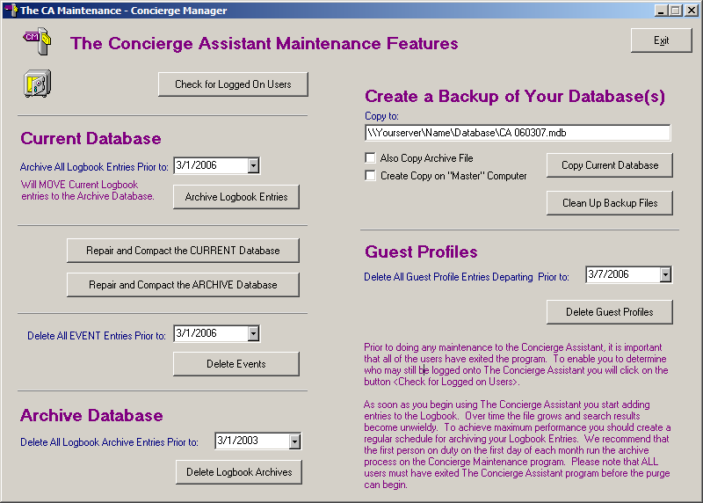

This will bring up a screen identical to the one below. You will then press on the button “Get Users”

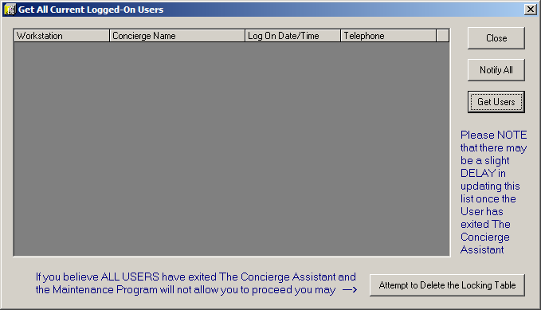

The Concierge Assistant will tell you the names of the users still signed on, as well as their computer name and telephone number (if provided with the staff member’s name).

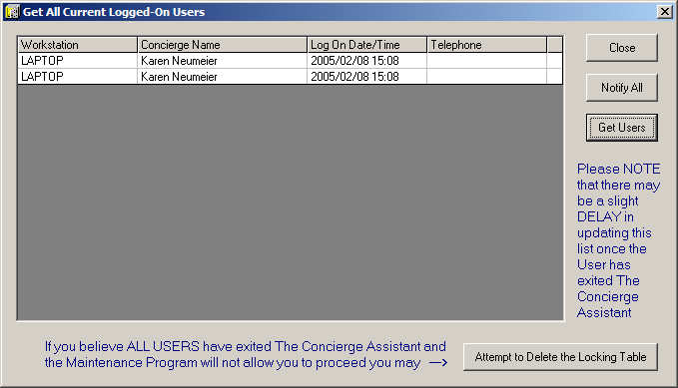

If there are still people logged onto the Concierge Assistant, you will then need to press the button “Notify All”.

The system will generate a message to the user that looks like this:

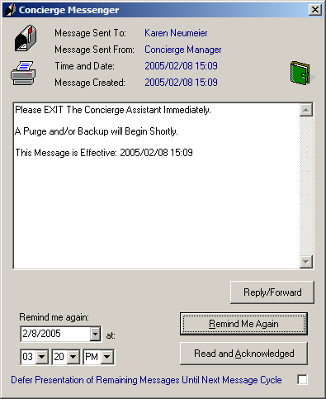

Please NOTE that there may a slight delay in updating this list once the User(s) has exited The Concierge Assistant. Give the system a few minutes before Checking for Logged On Users again to ensure that everyone has exited the system.

If you believe that ALL USERS have exited the Concierge Assistant program and the Maintenance Program will not allow you to proceed, you may now select the button labeled “Attempt to Delete the Locking Table”.

If ALL USERS have indeed exited the system, the following screen will appear, telling you that you may proceed with your selected maintenance.

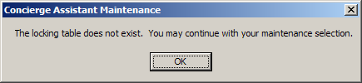

If ALL USERS have NOT exited, the following message will appear, denying you the ability to perform your selected maintenance.

